1. OVERVIEW

As an approved provider under HESA, UWA is required to provide data on students and courses to the Department of Education (henceforth the department) through the Higher Education Student Collection. The University submits files of data which are prepared according to specifications which can be found at

<http://heimshelp.education.gov.au/sites/heimshelp/2014_data_requirements/2014higheredstudent/pages/he-student-2014>

You should continually refer to the information on the above website. It’s the basis for everything we do in Collections!

Almost every submission is validated and submitted to the department via HEPCAT.

(information on HEPCAT can be found at <http://heimshelp.education.gov.au/sites/heimshelp/resources/toolkits/pages/reporting-with-hepcat>)

The collection is composed of the following submissions:

Course of Study submission

The Course of Study (CO) file contains information on all courses to be provided for a reporting year. Information included on this file is incorporated into published reports and also appears on the *MyUniversity* website.

Date due: 1 Aug

Campus submission

The Campus (CM) file contains information that supports the publication of higher education course information on the *MyUniversity* website. The CM file also includes information on offshore courses to support the Transnational Quality Strategy.

Date due: 1 Aug

Student submission

The Student submission includes data from three files; the Student Enrolment (EN) file, the Student Load Liability (LL) file and the Commonwealth Assisted Students - HELP Due (DU) file.

The data reported in the Enrolment (EN) file provides a profile of each student (e.g. date of birth, gender, home location, country of birth). Each record provides information for a particular student/course combination for a reporting period.

The Student Load Liability (LL) file contains records of student load (equivalent full time student load or EFTSL) and liability (or debt) for all units of study undertaken in the reporting year.

The Commonwealth Assisted Students (DU) file, commonly referred to as the ‘HELP Due’ submission, reports the personal details, including names, tax file numbers (TFN) and Commonwealth Higher Education Student Support Numbers (CHESSN) of all Commonwealth assisted students.

Dates due:

31 Mar (for units with census dates 1 Sep – 31 Dec of the preceding year)

31 May (for units with census dates 1 Jan – 31 Mar of the reference year)

31 Aug (for units with census dates 1 Apr – 30 Jun of the reference year)

31 Oct (for units with census dates 1 Jul – 31 Aug of the reference year)

Unit of Study Completions submission

The Unit of Study Completions submission includes data from one file only; the Unit of Study Completions (CU) file. It records the completion status for each unit of study undertaken by students in the reporting year.

Date due: 30 Apr

Past Course Completions submission

The Past Course Completions submission includes data from one file only; the Past Course Completions (PS) file.

It contains information about all courses completed by domestic and overseas students undertaking a course of study leading to an organisation’s higher education award.

Date due: 30 Apr

SA-HELP submission

The SA‑HELP submission includes data from two files; the SA‑HELP (SA) file and the Commonwealth assisted students (DU‑HELP Due) file.

The SA‑HELP (SA) file contains records about students who receive a SA‑HELP loan.

Dates due:

31 Mar (for debt incurral dates 1 Jul – 31 Dec of the preceding year)

31 Aug (for debt incurral dates 1 Jan – 30 Jun of the reference year)

OS-HELP submission

The OS‑HELP submission includes data from two files; the OS‑HELP (OS) file and the Commonwealth assisted students - HELP Due (DU) file.

The OS‑HELP (OS) file contains records of students who receive OS‑HELP assistance.

Dates due:

31 Mar (for debt incurral dates 1 Jul – 31 Dec of the preceding year)

31 Aug (for debt incurral dates 1 Jan – 30 Jun of the reference year)

Commonwealth Scholarships submission

The Commonwealth Scholarship submission includes data from one file; the Commonwealth Scholarship (CS) file. It contains records of students in receipt of various Commonwealth scholarships.

Dates due:

31 Mar (for students receiving the scholarship in the 2nd half of the preceding

year)

31 Aug (for students receiving the scholarship in the 1st half of the reference

year)

Student Revisions submission

Student load/liability data is revised using a Student Revisions submission.

The Student Revision submission includes data from three files – the Revised load/liability (RL) file, the Student Revision (SR) file and the Commonwealth assisted students (DU – HELP Due) file (also called the RD file in Callista).

The Revised Student Load Liability (RL) file enables providers to revise previously reported student load liability data.

The Student Revision (SR) file includes the key elements needed to identify unit of study record(s) requiring revision or deletion.

Date due: at any time where revisions are deemed necessary.

Enrolment Revisions submission

The Enrolment Revisions submission enables providers to revise student enrolment data that has previously been reported to the department on the Student Enrolment (EN) file in a Student submission.

Date due: at any time where revisions are deemed necessary.

OS-HELP Revisions submission

The OS‑HELP Revisions (OR) file is one of three files incorporated in the OS‑HELP Revisions submission. The other files are the Revised OS‑HELP (RO) file and Commonwealth Assisted Students (DU).

The OR file includes the key elements needed to identify OS‑HELP record(s) requiring revision or deletion.

The RO file has the same scope as the OS file.

The OS‑HELP Revisions submission enables providers to revise data that has previously been reported to the department in an OS‑HELP submission. The submission reports details of deletions or changes due to administrative error and remission of OS‑HELP debts.

Date due: at any time where revisions are deemed necessary.

Campus Deletions submission

The Campus Deletion (CD) file enables providers to delete campus records that have been previously reported on a Campus submission. These records may have been reported in error or the course may no longer be delivered from the reported campus location.

Once a campus record has been deleted it will no longer display on the *MyUniversity* website.

Dates due: at any time where deletions are deemed necessary.

University Applications and Offers submission

This submission includes data from three files; the Application Details (AD) file, the Preference Details (PD) file and the Offer Details (OD) file.

The Application Details (AD) file comprises data records for applications for admission to an undergraduate award course submitted directly to UWA.

The Preference Details (PD) file comprises data records for all preferences listed on an application for current undergraduate award courses submitted directly to UWA.

The Offer Details (OD) file comprises data records for all offers and responses to offers for admission to an undergraduate award course made directly to UWA

Date due:

Mid-March for a reference date in mid-Feb.

Late May for a reference date in mid-May.

**Outlined below are the basic procedures for producing the above data files for eventual submission to the department’s Higher Education Information Management System (HEIMS). There are also references to other documents with more detailed procedures for a given submission.**

2. Higher Education Student Data Collection: File Naming Convention

All the files (apart from Revisions and Commonwealth Scholarships) imported into HEPCAT adhere to the following file naming convention:

1055xxyyyy.pnnnnn where:

1055 = UWA provider code (numeric)

xx = abbreviated file type code (e.g. ‘EN’ or ‘en’)

yyyy = reporting year (numeric)

p = reporting period (numeric; 1 or 2)

nnnnn = submission number (numeric; 00001 to 99999)

For revisions files, the reporting year (yyyy) is always coded as ‘0000’ and the reporting period (p) is always coded as ‘0’.

1055xx yyyy.pnnnnn where:

1055 = UWA provider code (numeric)

xx = abbreviated file type code (e.g. ‘SR’ or ‘sr’)

yyyy = reporting year (numeric; always 0000)

p = reporting period (numeric; always 0)

nnnnn = submission number (numeric; 00001 to 99999)

Note that the submission number must follow sequentially from the last revisions file you have submitted.

The Commonwealth Scholarships file has the file name format: 1055CSyyyy.00001 (i.e. no character for reporting period)

3. The HEIMS dump

All the data submitted to the Department of Education ends up in a great big database called HEIMS. Now, if we never submitted revisions, the data in HEIMS would exactly match all the original data files we import and validate via HEPCAT. Except that we submit revisions – lots and lots of revisions, mostly of the Load Liability kind. The quickest and most fool-proof way of knowing what data HEIMS currently holds with regard to our students is to … drum-roll … ask for the data back! This is commonly called “the (data) dump”.

A request for the EN and LL “dumps” must be sent via email to the HEIMS folk in Canberra and they will create two CSV files which they will deposit to their file transfer site for us to download.

The site is: <https://filetransfer.deewr.gov.au>

Login/password held by the Collections team (currently Rob and Latha).

The EN and LL .csv files are then imported into two MS Access databases located under:

P:\staff\rrispoli\saswork\srstats\HEIMS\1055_Enrolments, and P:\staff\rrispoli\saswork\srstats\HEIMS\1055_LoadLiabilities

respectively. The tables are then read by SAS program create SAS datasets.sas (located in folder P:\staff\rrispoli\saswork\srstats\HEIMS).

Two SAS datasets are created (enrolments and loadliabilities) and the README file is updated to reflect the current state of the dump.

The dump is an invaluable source of data and must be kept up-to-date for all the submission programs below that use it.

Request a dump after each major Student submission at the very least!

4. The ATO Encryption Key

Any submission in HEPCAT that involves the transmission of HECS-Due records to the ATO requires entry of the ATO Encryption Key. This is kept under lock and key by the Collections Team. HEPCAT will prompt the user for the key to be entered if and when it’s required. Currently, the following submissions require the key:

* Student submission
* SA-HELP submission
* OS-HELP submission
* Student Revisions submission (only if students with a HECS debt are reported)
* OS-HELP Revisions submission

Oddly enough, the expiry date of the most recent key is supposedly 30 June 2006.

However, it still works and nobody’s ever sent us a new one.

So much for security!!

5. A Note on HDR Student Load

5.1 Research Load Adjustments

Prior to every Student submission, the Collections Team must check to make sure HDR students are enrolled in research unit codes appropriate to their candidature attendance percentage.

For example, a PhD student enrolled in units worth 24 credit points in a given semester (a full-time load) should not have an attendance percentage of 50%. There’s one of three possibilities: the student is enrolled in the wrong research units; or the attendance percentage is incorrect; or the unit enrolled credit points should be manually overwritten in Callista to get consistency between the credit points and the attendance percentage.

Unlike a bygone era, the modern-day Collections Team now no longer makes the decision on what data needs to be modified. It’s entirely upto the Graduate Research and Scholarships office. After all, it’s not up to Planning Services to decide what EFTSL should be reported for any given HDR student!

To make the job easy for GRS, we run a SAS program called:

res_load_adjust.sas

which can be found in:

P:\stats\srstats\DEET*nn*\Student\Research Load Adjustments

The program produces 9 spreadsheets which, after checking, should be forwarded to the appropriate officers in GRS. They are quite familiar with the contents and will make all necessary adjustments. I would recommend running the program a couple of weeks either side of a submission’s census date.

5.2 Identifying Time Limit Students

A student who has exceeded the maximum time for enrolment in a place funded under the Research Training Scheme is referred to as a time limit student. Time limit applies only to domestic students because only domestic students can access an RTS place. HDR students enrolled on a fee-paying basis are not subject to external time limits.

The maximum time limits for full-time attendance (or the part-time equivalence) are 4.0 EFTSL for a Doctorate and 2.0 EFTSL for a Master's degree by research.

At the same time the research load adjustment reports are created, another SAS program is run to identify those students who have exceeded their RTS funded EFTSL.

The SAS program is called:

GetLimit-mod.sas

and is located in folder:

P:\stats\srstats\DEET*nn\S*tudent\Time Limit Checking

The resulting spreadsheet is sent to GRS for checking and student status codes are modified accordingly.

6. The Course of Study submission

The basis for the 1st CO file submission is the data file created within the Callista Statistics Subsystem.

Before proceeding with the Callista job, a record must be added to the Government Snapshot Control form in Callista (STAF1350), as follows:

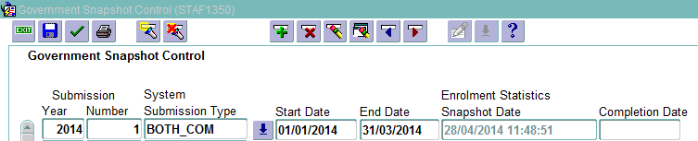

Callista job: STAJ0040

This job only creates records containing details of the courses studied by the institution's students during the current submission year and the previous submission year. The file is created in accordance with the department’s file specification, for loading into HEPCAT.

The process determines the courses to report, by:

finding those Course Offering Instances offered in academic periods which are linked to government semesters, for this and the previous submission year, and

checking that the course is 'Government Reportable'.

Unfortunately, this means that a number of courses to be offered in the following year – and which are reported in the Campus (CM) file (every record in the CM file requires a matching record in the CO file) – will not appear on the CO file created by STAJ0040.

That’s why a SAS program has been written to read in the CO file from Callista, compare data with the previous year and add additional records if necessary. The program then creates another CO file ready for importing into HEPCAT.

SAS program folder name: P:\stats\srstats\DEET*yy*\Student\Campus and Course files

SAS program file name: course file.sas

Further instructions and comments regarding the process, together with the actual CO file itself, can be found under the SAS program folder mentioned above.

The CO file is then imported into HEPCAT, validated and submitted to HEIMS.

7. The Campus submission

There is no Callista job for the creation of the Campus (CM) file.

There is, however, a SAS program which will create it for you!

You will need to create the relevant CO file first (see section 2).

SAS program folder name: P:\stats\srstats\DEET*yy*\Student\Campus and Course files

SAS program file name: campus.sas

Before running the program, there are various spreadsheets which you’ll need to source.

TER_BY_COURSE_CD.XLS: contains TISC cut-off ATARs – by course - for previous

year’s admissions

1055-UWA-*yyyy*.xls: a dump of all of UWA’s Campus records as held on HEIMS

(needs an email request to be sent to the department)

*yyyy* Course Changes.xls: a list of courses to be rescinded to be obtained from Larissa

Stone. (Information not yet available on Callista)

*yyyy* FPPG prelim.xls: preliminary fees for fee-paying PG domestic students

provided by the Senior Fees Officer (currently Kara Lopes).

These will be used by the program to calculate indicative

fees.

The program has various checks built into it to make sure there is consistency from year to year and the elements cross-check. Have faith in it but do NOT disregard any warnings!

Further instructions and comments regarding the process, together with the actual CM file itself, can be found under the SAS program folder mentioned above.

8. The Student submission

There are four Student submissions in any given year.

The due dates and the census dates incorporated into the four submissions are listed in section 1.

Each of the four submissions requires an entry in STAJ1350.

As an example, here are the four entries for 2013:

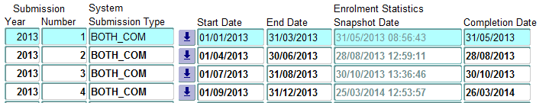

(ignore data entered into the last two columns)

After setting up STAJ1350, we’re ready to go!

There is very good online documentation available on Callista titled *Understanding HE Statistics*. I strongly encourage you to read it.

In short, production of a Student submission involves determining that a particular Enrolment Snapshot reflects the enrolment situation at the Census Date. This Enrolment Snapshot may by necessity have been created after the Census Date, to allow for processing of retrospective Enrolment/Discontinuation transactions.

The Government Submission Snapshot process (STAJ0110) is run via Job Scheduler. It uses the chosen Enrolment Snapshot to identify which records to consider for reporting in the Government Submission (via the Government Reportable check box), and as a source of some data. The remaining required data is extracted or derived from other parts of the system. Other checks are performed by the system to determine if records should be included in the Government submission (for example, 'Is unit enrolled as at the Census Date?).

Here’s a neat flow diagram (shamelessly copied from *Understanding HE Statistics*) which helps to explain the process:

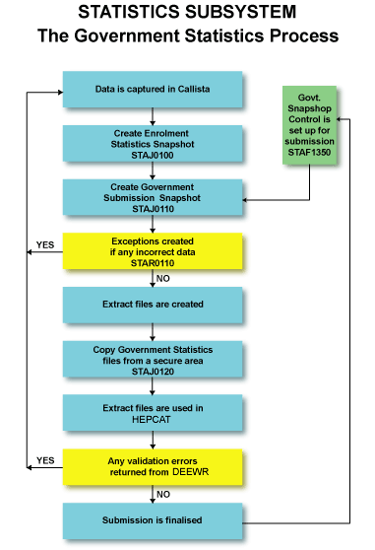

The Callista jobs are run as follows:

STAJ0110: creates a snapshot of Enrolment and Load data.

(run using the latest Enrolment snapshot)

STAJ0090: creates the Student Enrolment (EN) file.

STAJ0140: creates the Student Load Liability (LL) file.

STAJ0050: creates the Commonwealth Assisted Students - HELP Due (DU) file.

UWAJ0380: this is a UWA produced program which appends relevant records to the

uwa_stdnt_ext_enrolments table in Callista. It will be used in the SAS program

below.

The files created by the last three jobs can be collected from the ‘*Simsprod – keep*’ directory.

You should deposit them under the server folder:

P:\stats\srstats\DEET*yy*\Student\Student Submissions\Submission *n* (where *yy* is the reference year and *n* is the submission number.)

and append the following to the file names:

“(before course code conversion)”

So, for example, 1055EN2014.100001 becomes 1055EN2014.100001 (before course code conversion).

Before importing the files into HEPCAT for validating, there’s a fairly substantial SAS program which needs to be executed.

SAS program folder name:

P:\stats\srstats\DEET*yy*\Student\Student Submissions\Submission *n*\SAS Programs

(where *yy* is the reference year and *n* is the submission number.)

SAS program file name:

convert_course_codes_s*n*.sas

(where *n* is the submission number.)

The original reason for this program’s creation was to extend the course codes for HDR students so that they could be identified as low/high cost for RTS funding purposes. It is still used for this purpose. However, it now incorporates various checks and minor fixes – too numerous to mention – prior to importing into HEPCAT for the final validations.

PLEASE NOTE: the fixes made by this program are very minor and do not affect the data stored in Callista. Major changes are ALWAYS fixed in Callista prior to producing the output files.

The files produced by the SAS program are located in: P:\stats\srstats\DEET*yy.*

The final step in a Student submission is, of course, validating the data in HEPCAT.

Any FATAL errors MUST be reported to Student Services so that data can be fixed at source i.e. in Callista. A program called error_program_s*n*.sas located in the SAS folder above will help in extracting relevant information from the Excel error files exported out of HEPCAT.

Over the course of a submission, the procedures above are repeated many, many times! By the end of a submission, we’ve just about had more than enough of the damn thing! What I’m trying to say is: it takes patience, dedication and a great deal of communication with Student Services to get clean files ready for submitting to HEIMS. It ain’t sexy but someone’s gotta do it!

As always, further instructions and comments regarding the process can be found under the SAS program folder mentioned above.

9. The Unit of Study Completions submission

As usual, a record must be added to the Government Snapshot Control form in Callista (STAF1350), as follows, before we begin the process of creating a UoS Completions submission:



Callista job: STAJ0150

This job is actually run TWICE for reasons which are very well explained in the document

*How to proceed with Units of Study completions reporting.docx*

located in folder:

P:\stats\srstats\HEIMS\UOS completions revisions

Make sure you read it! It has everything to do with revisions and when and why we have the Completion Date set in STAJ1350.

After you’ve read that masterly document, you’ll have deposited two CU files in folder:

P:\stats\srstats\DEET*yy*\Student\Unit of Study Completions

called

1055CU*yyyy*.100001(from Callista), and

1055CU*yyyy*.100001(from Callista with revisions)

There are now THREE SAS programs which need to be run, also located under:

P:\stats\srstats\DEET*yy*\Student\Unit of Study Completions

Run in the following order:

1. add grade to CU file.sas  
   A complicated program which tries to get results for the ‘AC’ graded units with a fair bit of trickery and pokery! Not for the faint-hearted!  
   You WILL require an Excel file from Larissa Stone called:  
   Full Year Unit Lists *yyyy*.xls which contains a list of unit codes that are really one full-year unit so that the last one in the series gets the result!
2. cu revisions.sas   
   If you read my document called *How to proceed with Units of Study completions reporting.docx* this will all make sense!
3. convert_course_code_for_DEEWR CU file.sas  
   Another masterly program that grabs the extended course codes from the HEIMS dump.

After running all three programs you will have the CU file for the given year.

Import and validate in HEPCAT prior to submission.

10. The Past Course Completions submission

We begin by adding a record to the Government Snapshot Control form in Callista (STAF1350), as follows:



Note the start and end dates! Very deliberately set as 1 April and 31 March so that we capture any late course completion records added to Callista.

We also very deliberately never enter anything into any of the CRS-COMP Completion Date fields. That’s because the suite of SAS programs we run in the process of creating the final PS file create additional completions records for the two years prior to the reference year – which is more than enough!

Callista job: STAJ0070

Only the parameter called “Submission Year” is relevant.

We do NOT “Include Revision Records” for reasons given above.

The job is run for the most recently completed year and the two years prior to that.

Files are deposited under folder:

P:\stats\srstats\DEET(*yy+1*)\Student\Past Course Completions\full year.

So, for example, if processing course completions for 2013, we place the relevant files in folder:

P:\stats\srstats\DEET14\Student\Past Course Completions\full year

Now you’re probably asking yourself: why the hell are you putting 2013 completions in a 2014 folder? This is one of the many Koon Quek (or is it Luke Minchin?) mysteries which may never be properly explained.

You may also ask yourself: why the hell doesn’t the current Collections Coordinator fix this very apparent anomaly in folder storage convention? Well, things would break! And I don’t want to be responsible for the ensuing chaos!!

All of the SAS programs relating to this submission can also be found under folder:

P:\stats\srstats\DEET(*yy+1*)\Student\Past Course Completions\full year.

Under that folder there’s a handy little .txt file called *Notes on running these programs.txt*.

You absolutely must read it or you’ll never understand the order of things! It really is bizarre! And one day it will all be re-written. But for the time being we’re stuck with a bunch of SAS programs cobbled together over the years which produce a decent set of completions records.

At least the data are comparable from year to year and that’s very important!

While running the multitude of SAS programs you MUST read the comments in the programs and heed the advice given.

After running the final program (convert_course_code_for_DEST PS.sas) you will have produced the PS file ready for importing and validating in HEPCAT.

Note: there will ALWAYS be course codes in the PS file which will not have been submitted to HEIMS for the completion year in question. Don’t panic! HEPCAT will flag them as FATAL errors. The SAS program will do its best to create CO records for these courses. However, you must create another Course submission in HEPCAT, and submit it, prior to submitting the Past Course Completions submission.

11. The SA-HELP submission

There are two SA-HELP submissions for any given year.

The due dates and the incurral dates for the two submissions are listed in section 1.

Each of the two submissions requires an entry in STAJ1350.

As an example, here are the two entries for 2013:

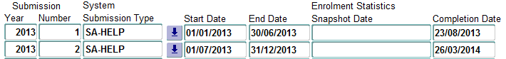

Callista job: STAJ0180

The job creates the SA‑HELP (SA) file which should be placed in folder:

P:\stats\srstats\DEET13\Student\SA-HELP\Submission *n*

There is no SAS program required to process this file.

Because there is no need to create extended course codes for the HDR students in the SA-HELP file (low/high cost doesn’t enter into it!), there may be the necessity to create additional ‘generic’ course codes (e.g 00810 for the PhD) and submit them via a Course submission prior to submitting the SA-HELP file. This can usually be done by grabbing the CO file created for just this purpose from a previous year’s SA-HELP folder and changing the reporting year at the end of each record.

There’s also a strong chance that you will be missing HECS Due records, especially for the PhD students who wouldn’t normally have any sort of debt due apart from SA-HELP. (Honestly, isn’t it that hard to come up with 100 bucks every 6 months!)

In this case, if you run STAJ0050 again after running STAJ0180, you’ll pick them up. Then just pick the relevant records, chuck them in a DU file and append to the existing DU submission in HEPCAT. Re-validate the DU submission then validate the SA-HELP file and all should be peachy! If it isn’t then you may have to create DU records from scratch! (But don’t worry, there’s a sneaky SAS program written for just such a situation!)

Don’t forget to enter the Completion Date in STAF1350 once the data has been submitted to HEIMS.

Callista also has the ability to create SA-HELP revisions.

A SA-HELP revisions submission requires an entry in STAF1350 such as the following:

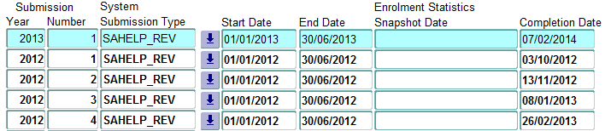

As you can see from the above, there were four SA-HELP revisions submissions for 2012 1st half-year data and one for 2013 data at the time of writing this document.

Once again STAJ0180 is run with a System Submission Type of SAHELP_REV.

The file created has exactly the same structure as a regular SA-HELP (SA) file.

As for a regular submission, don’t forget to enter a Completion Date for the SA-HELP Revision submission in STAF1350 once the data have been submitted.

12. The OS-HELP submission

There are two OS-HELP submissions for any given year.

The due dates and the incurral dates for the two submissions are listed in section 1.

Each of the two submissions requires an entry in STAJ1350.

As an example, here are the two entries for 2013:

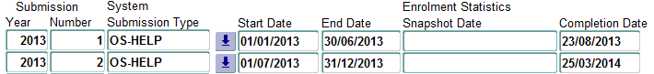

Callista job: STAJ0160

The job creates the OS‑HELP (OS) file which should be placed in folder:

P:\stats\srstats\DEET13\Student\OS-HELP\Submission *n*

There is no SAS program required to process this file.

As with the SA-HELP submission, there’s also a fair chance that you will be missing HECS Due records, especially for the PhD students who wouldn’t normally have any sort of debt due apart from OS-HELP (or SA-HELP!).

In this case, if you run STAJ0050 again after running STAJ0160, you’ll pick them up. Then just pick the relevant records, chuck them in a DU file and append to the existing DU submission in HEPCAT. Re-validate the DU submission then validate the OS-HELP file and all should be peachy!

Don’t forget to enter the Completion Date in STAF1350 once the data has been submitted to HEIMS.

13. The Commonwealth Scholarships submission

This submission is quite different to all the others mentioned in section 1.

The data are NOT imported/validated nor submitted via HEPCAT.

Instead, one must submit data via an antiquated website located at:

<https://admin.heims.deewr.gov.au>

(Warning! Use Internet Explorer or the bloody thing won’t work correctly!)

As indicated in section 1 of this document, there are two submissions of CS files to HEIMS – one for each half-year.

The process begins with somebody in the Collections team requesting Bronwyn (in SIMS) to upload the data which will be provided by the Scholarships Officer in GRS at least one month prior to the due date. We can then run the appropriate Callista job.

But not before you set up STAF1350 (thought I’d forgotten, didn’t you!?). Here’s the two entries required for submission 1, 2013:





Change the Submission Number to ‘2’ for submission 2.

Callista job: STAJ0130

The program is run twice each submission, once for each System Submission Type.

Deposit the two files in folder:

P:\stats\srstats\DEET*yy*\Student\Scholarship files\Submission *n*

and append the System Submission Type to the files.

So, for example, for submission 1, 2013 there would be two files, called

1055CS2013.00001(SCHCASIP) and 1055CS2013.00001(SCHLSHP)

in folder

P:\stats\srstats\DEET13\Student\Scholarship files\Submission 1

We then run a SAS program called:

check and submit sub *n yyyy*.sas

which does some basic error checking and minor corrections as well as producing ONE CS file ready for uploading to HEIMS via the website mentioned above.

Prior to running the SAS program, make sure you have a “dump” of UWA records from the previous submission (i.e. records exported to an Excel from HEIMS).

This means that if you’re processing sub 2 data for 2013, the SAS program will expect a file containing a dump of sub 1 records, called:

P:\stats\srstats\DEET13\Student\Scholarship files\Submission 1\HEIMS Summary Export 2013 sub1.xls

to exist.

How does one go about getting this Excel file (we will continue using sub1?

Login to <https://admin.heims.deewr.gov.au> using Internet Explorer and click on Submission Report Summary:

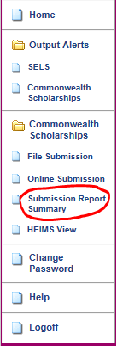

You will see a list of all UWA’s previous submissions.

In our case, we select the 1st submission of 2013:

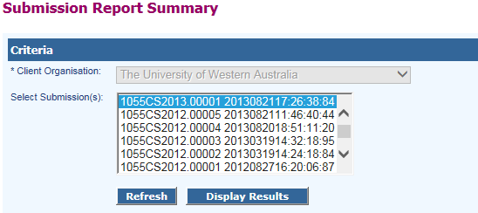

and click on Display Results.

Then click on Export All Data. Save as the file mentioned above and clean it up a little (just look at a previous year’s file to see what it looks like).

We then run the SAS program. Check the log for errors and get back to SIMS/GRS with any data corrections that may be necessary.

If there are fixes to be made to the Callista data you will have to repeat the whole process described above (Collections is fun!) until the program doesn’t produce anymore errors.

We are then ready for submission!

Once again, go to <https://admin.heims.deewr.gov.au> and login. Click on File Submission:

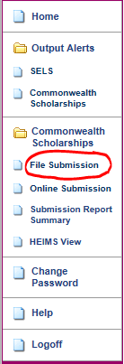

and follow the on-screen instructions.

At the end of this submission process, you will probably get a few records that failed to load.

Make sure you report the failed records to GRS.

Mostly, the errors fail to load because the students have run out of entitlement. In this case, they have rightly failed and GRS will have to discuss the matter with the students involved. If the failed errors are due to other reasons, discuss with GRS whether another mini-submission is necessary or whether they can talk to the HEIMS team directy.

Usually it’s the latter and we’re done for yet another submission!

As always check the README files located in the folder mentioned above for any notes related to a specific submission.

14. The Student Revisions submission

A Student Revisions submission is the most tricky and complicated procedure performed by the Collections Team.

There are quite a few other documents discussing this submission so I’ll only cover the essential steps involved in a typical submission in this manual.

Let’s assume we are doing a Student Revisions submission for 2013.

We normally begin by running the Callista jobs on one of the “test” servers.

This can be SIMSQRY if you intend doing all the initial work in one day (SIMSQRY is refreshed nightly) or on SIMSWKLY if you want more time (SIMSWKLY is refreshed every weekend). The obvious problem with running the jobs on SIMSWKLY is that the data can be up to a week old. Nonetheless, I tend to favour SIMSWKLY in case other work arises during the day and you can’t finish all the initial groundwork in one day.

So here are ALL the steps involved in a Student Revisions submission:

1. Decide on which year’s data you’re wanting to revise.  
   In our case, it will be 2013.
2. Pick an environment – usually SIMSWKLY, SIMSQRY or, in rare circumstances, SIMSPROD. We will choose SIMSWKLY for this exercise.
3. Set up STAF1350 as follows:

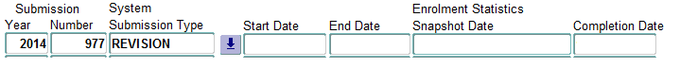  
Let me talk about the choice of Submission Year.

This is NOT the year of the data you’re wanting to revise. It’s normally the year of the Student submission you’re currently working on. So, in our case, say Latha is working on a regular Student submission 1 for 2014 and we want to run revisions for 2013. Then the year entered above must be 2014. That’s so that any brand new records for units with 2013 census dates will be reported by Latha in the 1st 2014 submission. Let me repeat: it’s only an issue for brand new records – by which I mean unit of study records at a 2013 census date for which the student in question did not have any other units at that census date.

Submission Numbers are chosen consecutively and we normally associate a memorable name with the submission number – in this case ‘Nepal’, for no particular reason!

It’s fun trying to come up with a name.

1. Run Callista job STAJ1610 three times. Each of the three runs will have the same settings for the ‘Parameters’ tab on the form:

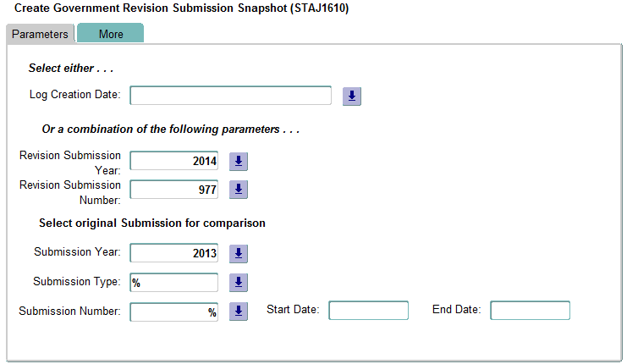

Run #1 will have the following settings on the ‘More’ tab:  
  
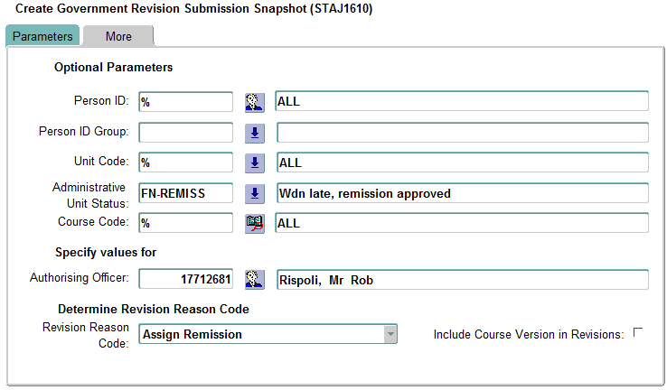  
Run #2 will have the following settings on the ‘More’ tab:  
  
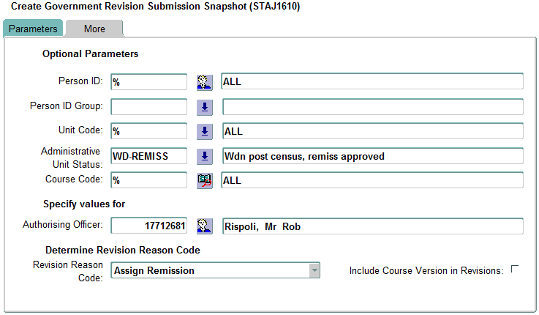  
and, finally, run #3 of STAJ1610 will have the following settings on the ‘More’ tab:  
  
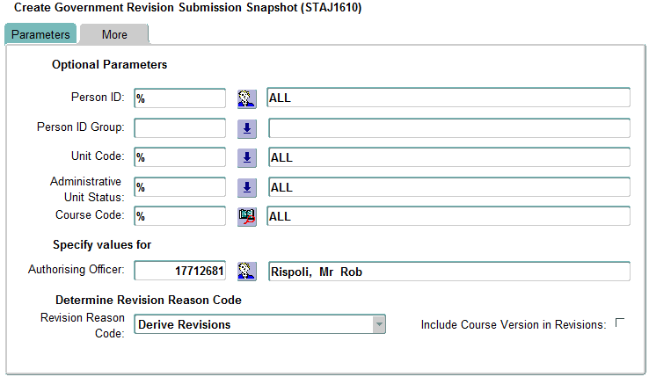  
These 3 jobs will populate the following Callista tables with records where REVISION_SUBMISSION_NUMBER is 977:  
 GOVT_STUDENT_REVISION  
 GOVT_STDNT_LIABILITY_REVISION, and  
 GOVT_EXT_STUDY_LOAN_REVISION

There’s usually a problem with the records produced by the program for the GOVT_EXT_STUDY_LOAN_REVISION table. They’re meant to be 2013 revisions to OS-HELP records but for some strange reason the Callista job STAJ1610 also populates it with data that has incurral dates in 2014! These records MUST be deleted – but we’ll talk more about this when we come to the part that deals with running everything on SIMSPROD. For the time being, since we’re running the jobs in a ‘test’ environment, we can ignore the GOVT_EXT_STUDY_LOAN_REVISION table.

1. Check the three .pdf files created by the three STAJ1610 jobs.  
   These can be picked up from the ‘output’ folder.  
   Make sure you heed any errors reported on these reports.
2. Set up a folder on the file server.  
   The naming convention for a folder on the file server which contains all files related to a Student Revisions submission is as follows:  
     
    P:\stats\srstats\DEET*yy*\Student\Revisions submissions\Revisions *nnn* (*insert funny name*) – *YYYY*  
   where yy is the Submission Year, *nnn* is the Revision Submission number and *YYYY* is the year of the data you’re revising.  
   In our case the folder name will be:  
     
    P:\stats\srstats\DEET14\Student\Revisions submissions\Revisions 977 (Nepal) - 2013  
     
   In every Student Revisions folder you’ll find a README file with invaluable information related to the submission.
3. Run SAS program check1.sas.  
     
   This program is run to perform some basic data checks (against a HEIMS dump), identify genuine revisions – as opposed to those where only the Maximum Student Contribution Indicator (MSCI) has changed – and create the person ID group (PIG) file.  
     
   Let me explain further.  
     
   Unfortunately Callista job STAJ1610 doesn’t always calculate E392 (MSCI) correctly.  
   In my opinion, E392 is more trouble than it’s worth! In the case of revisions it’s totally worthless because only the amounts charged for a unit are meaningful and we know that the fees are being correctly calculated by the SIMS team. So, sometimes, the only change in a student’s Load Liability record will be related to the MSCI. We are NOT interested in reporting these changes to HEIMS and the check1 program will identify and remove these students. The remaining student IDs, for ‘genuine’ revisions, get written to a file called PIG.TXT and this will be used to run the STAJ1610 all over again.
4. Having obtained our PIG we have a decision to make. Go straight to SIMSPROD with our PIG or stick to SIMSWKLY. Let’s assume we stick to SIMSWKLY. Then we must delete all records where REVISION_SUBMISSION_NUMBER is 977 on the following tables:  
    GOVT_STUDENT_REVISION (GSR)  
    GOVT_STDNT_LIABILITY_REVISION (GSLR), and  
    GOVT_EXT_STUDY_LOAN_REVISION (GESLR)  
     
   If we don’t delete the records and we run the STAJ1610 jobs again with our PIG file then Callista is going to make a meal of it!  
   Fortunately, the Collections Coordinator has the necessary permissions in Callista to be able to delete records in the three tables mentioned above.  
   There are two ways to delete the records. Either through a utility like SQLDEVELOPER, or in SAS.
5. Set up a PIG in Callista.  
   Fire up form IDGF1100.  
   Enter a Group Code – say REV977 – and a Description on the form and hit the save icon.  
   Click on Import File, navigate to:  
     
    P:\stats\srstats\DEET14\Student\Revisions submissions\Revisions 977 (Nepal) - 2013  
     
   and import PIG.TXT.
6. Armed with our PIG and having deleted all relevant records in SIMSWKLY, we can now go ahead and run the STAJ1610 jobs again. The ‘Parameters’ tab for all three runs is identical to that in step 4:  
     
     
   After clicking on the ‘More’ tab, click the down arrow on Person ID Group and choose REV977. Callista will return a PIG number in the field.   
   Run #1 settings on the ‘More’ tab will now look something like this:  
     
   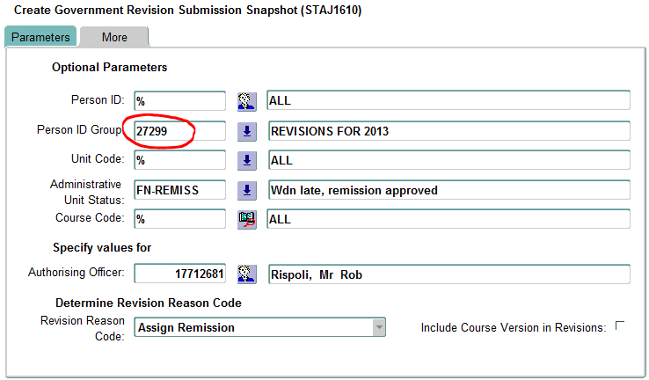  
   Run #2:  
   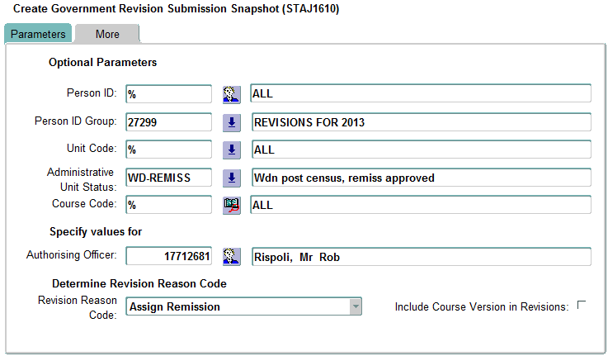  
   And run #3  
     
   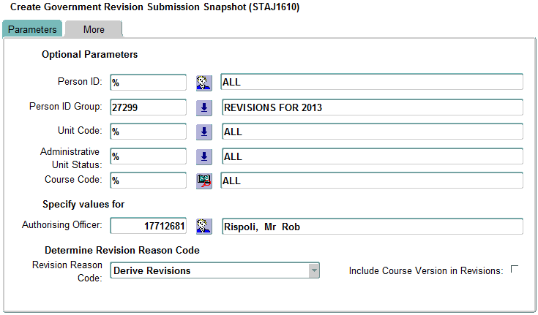
7. We now carry on with running the rest of the Callista jobs.  
   Run STAR1630 to create the submission report .pdf.  
   This report will identify the revisions and, most importantly, let us know the year(s) for which STAJ0100 must be run.
8. Run STAJ0100 for the years identified in step 11.
9. Run STAJ0110 with a Submission Year of 2014 and a System Submission Type of REVISION.
10. Run STAJ0050 with a Submission Year of 2014 and a System Submission Type of REVISION.
11. Run STAJ0140 with a Submission Year of 2014 and a System Submission Type of REVISION.
12. Run STAJ1620.
13. Run STAJ0160 but only if there are any ‘genuine’ revisions in table GOVT_EXT_STUDY_LOAN_REVISION (see notes in step 4). Or if you have no interest in doing OS-HELP revisions at this time, just ignore this step.  
    (It’s always amazed me that Callista lump OS_HELP revisions in with Student Revisions!)
14. Having run all the jobs above (and assuming there are no OS-HELP revisions – because there rarely are any!), there will be three files for us to pick up from the ‘keep’ folder on SIMSWKLY. They are the Revised load/liability (RL) file, the Student Revision (SR) file and the Commonwealth assisted students (RD) file.  
    Deposit them in folder:  
      
     P:\stats\srstats\DEET14\Student\Revisions submissions\Revisions 977 (Nepal) - 2013
15. Run SAS program: convert_course_codes_for_DEEWR.sas.

This program will cross-check against the HEIMS dump and pick up the course code under which the student units were first reported to HEIMS. If this is not done, the submission may fail due to records not matching on the key fields.  
The SAS program will create three equivalent files (SR,RL and RD) with a file name extension expected by HEPCAT.

1. Create a new REVISIONS submission in HEPCAT and import the SR and RL files created in step 19.

Validate the files.  
If there are any FATAL errors, get them corrected by Student Services and go back to step 10 and repeat through to step 20.

If there are any FATAL errors caused by a failure to find matching HECS-Due records in HEPCAT then you’ll need the RD file.   
Create a small DU file containing just the records for the students causing the FATAL errors. Append them to the LATEST HELP Due submission and re-validate this submission. Then re-run the validations for the Student Revisions submission. If there are still FATAL errors of this type then you’ve got bigger problems!  
  
If there are no more errors you’re clear to carry on.

1. Having successfully got to this step you may think it’s time to submit the Student Revisions data.  
   BUT NO!!!!!!!!  
   Remember that, up to this point, we’ve been running everything on SIMSWKLY.  
   We now have to run it on SIMSPROD because the records absolutely MUST be written to GSR, GSLR and the GOVT_STUDENT_LOAD_LIABILITY (GSLL) on SIMSPROD so that everything works in the future.  
     
   So, go back to step 3 (add entry in STAF1350 on SIMSPROD), then skip to step 10 and run all the steps 10-20 on SIMSPROD.
2. With any luck, there will be no differences in any of the three files coming out of step 18 on SIMSPROD. If this is the case, you’re clear to submit the Student Revisions submission on HEPCAT as it stand. However, if there are differences you’ll have to repeat step 19, re-import the data into the submission created in step 20, and then submit.  
   Either way, you’re almost there!
3. If, after submitting in step 22, you get the wonderful “success” email from HEIMS, then you can feel pretty pleased with yourself!   
   One more step!!  
   You must NOT forget to add a Completion Date to the relevant STAF1350 entry on SIMSPROD! Failure to do so will mean that the ‘brand new records’ will never be reported to HEIMS!

And that’s my take on Student Revisions!

15. The Enrolment Revisions submission

There are no supporting programs in Callista for Enrolment Revisions.  
That’s because they are rarely submitted.  
They usually become an issue if the HEIMS folk have detected some inconsistencies in our submitted Enrolment data and would like us to investigate and submit corrections to one or more elements previously submitted in a Student submission, prior to formal verification.

If you wish to submit an Enrolments Revisions submission in HEPCAT, please read the following documentation from HEIMS:  
  
 <http://heimshelp.education.gov.au/sites/heimshelp/support/revisions/pages/he-student-enrolment>

And that’s really all I’ve got to say about that.

16. The OS-HELP Revisions submission

OS-HELP Revisions are a by-product of the Student Revisions process.

Please read section 12, paying particular attention to step 17.

After running Callista job STAJ0160, an RO file will be created in the ‘keep’ folder.

Create a new OS-HELP Revisions submission in HEPCAT and import/validate the RO file.

There will rarely be any errors generated. If there are, you’re on your own, buddy!

Submit the file and bask in the glory of receiving yet another ‘success’ email from the HEIMS computer in Canberra.

17. The Campus Deletions submission

After submitting the Campus file (information from which is published on the *MyUniversity* website) way back on 1 August for the following year’s course offerings, we frequently discover that course information submitted in the Campus file has been modified (especially for new courses) and/or courses have been added or rescinded.

For modifications to courses previously submitted on the Campus file, we merely submit the records again – with modifications - in a new Campus submission for the given reference year.

For course additions, again we merely submit the records again in a new Campus submission for the given reference year.

Rescinded courses have their very own Campus Deletions (CD) file submission!

So, how does one go about creating all these records?

After submitting the original Campus file on 1 August, you will need to run the campus.sas program again, at least once a month, until Feb. of the next year.

Each ‘Campus Revision’ run will have its own folder (sub*n*) under the original folder:

P:\stats\srstats\DEET*yy*\Student\Campus and Course files

Run the SAS program: campus.sas

You’ll already have all the requisite Excel files, although there may be changes in the data on two of them, namely:

*yyyy* Course Changes.xls: a list of courses to be rescinded to be obtained from Larissa

Stone. (Information not yet available on Callista)

*yyyy* FPPG prelim.xls: preliminary fees for fee-paying PG domestic students

provided by the Senior Fees Officer (currently Kara Lopes).

These will be used by the program to calculate indicative

fees.

Carefully follow the instructions in the program.

At this stage, you may want to re-read section 5.

If the program picks up any additions or modifications, these data will be written to a new Campus file.

If the program determines that some courses have been rescinded, a CD file will be created.

To submit a Campus submission, see section 5.

To submit a Campus Deletions submission, create a new CD submission in HEPCAT.

Import and validate the CD file.

Submit!

Update the notes in the README file located under:

P:\stats\srstats\DEET*yy*\Student\Campus and Course files

18. The University Applications and Offers (UAO) submission

For some strange reason, the Department of Education treats the UAO submission quite separately from the Higher Education Student Collection. It has its own set of instructions found at:  
  
<http://heimshelp.education.gov.au/sites/heimshelp/2014_data_requirements/2014applicationsandoffers/pages/apps-offers-2014>

Nonetheless, the three files which comprise this submission are still processed and submitted via HEPCAT.

Due dates for the two annual submissions are found in section 1.

All files and information regarding this submission should be stored under:  
  
 P:\stats\srstats\DEET*yy*\Student\Applications and Offers\sub *n*

The first step involves setting up job parameters in Callista using form STAF1360.

Here’s an example of the two entries for 2014:  
  
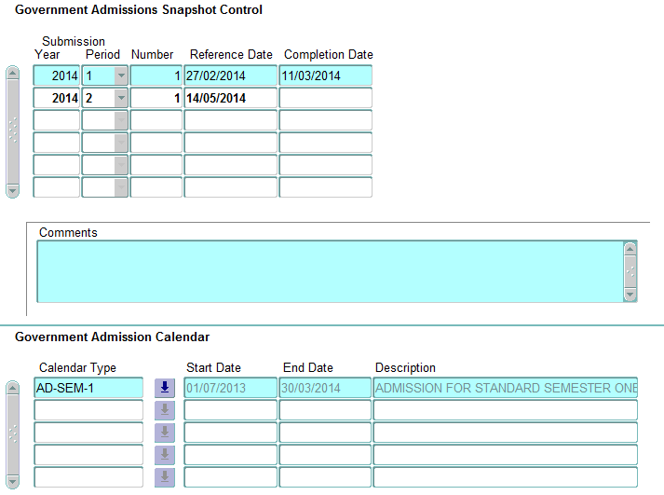

Note the following from the screen shot above:

* The Reference Dates (27 Feb and 14 May for 2014) are set by the department – refer to the HEIMS website for a given year’s dates
* You must choose a Calendar Type of AD-SEM-1 for the given year for both periods.
* A Completion Date has been entered for the period 1 submission, indicating successful submission of these data to HEIMS. Similarly, a Completion Date must be entered for period 2 following its successful submission.

Run Callista job STAJ0500 with appropriate values for Submission Year and Submission Period.

Run Callista job STAJ0510 with appropriate values for Submission Year and Submission Period making sure that you’ve ticked all three boxes indicating that you wish to create the Applications, Preferences and Offers files.

Sometimes, you might find that STAJ0500 fails. This will almost always be due to a preference number missing on a student’s application (see form ADMF3000) record.

The log will indicate the student ID in question.  
You will have to get the Admissions team to fix the data before running STAJ0500 again.

After successfully running STAJ0500 and STAJ0510, there will be three files (the Application Details (AD) file, the Preference Details (PD) file and the Offer Details (OD) file) waiting for you in the ‘keep’ folder of the Callista environment in which you chose to run the jobs.

Deposit them under the folder (P:\stats\srstats\DEET*yy*\Student\Applications and Offers\sub *n)* mentioned above.

As is the case with nearly all our submissions, there’s a nice SAS program to run.

For this submission it’s called: apo.sas

The program identifies inconsistencies in the data, suggests students that should be deleted, cross-checks against TISC data (we do NOT want to report applications that are also being reported by TISC!), fixes a few minor errors and, finally, creates new versions of the AD, PD and OD files ready for importing and validating in HEPCAT.  
Follow the instructions in the program and you won’t have too much trouble.

Ignore the instructions at your peril!

When the files are all ready, create a new ‘Application Details’ submission in HEPCAT with appropriate Reporting Year and Reporting ‘Number’ (period).

Import and validate.

Rinse and repeat until all FATAL errors are gone and WARNINGs have been investigated.

Submit in the usual fashion.